# CCET 3680 Mill Lesson 2 Second Exercise

I. Wireframe:

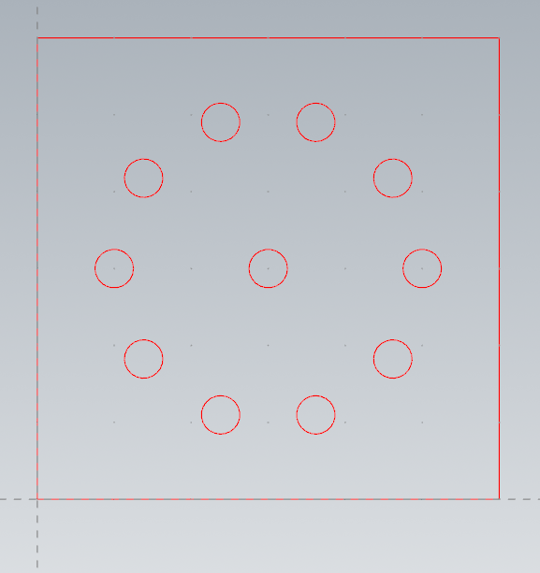

II. Dimensions:

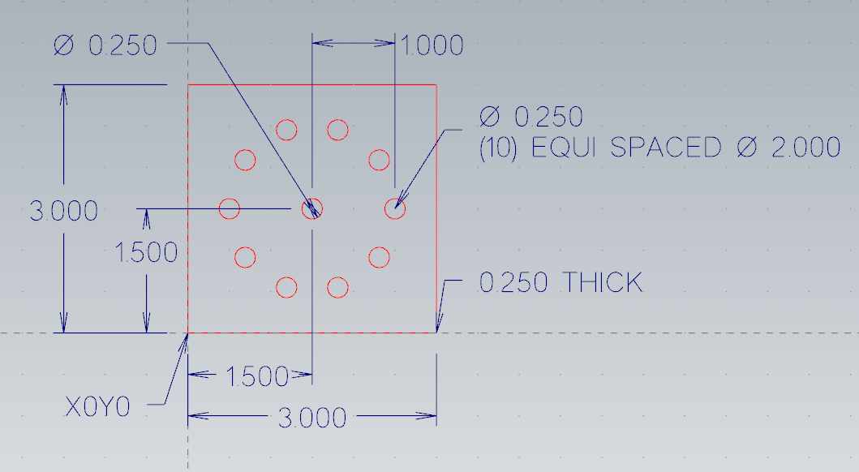

III. Solid:

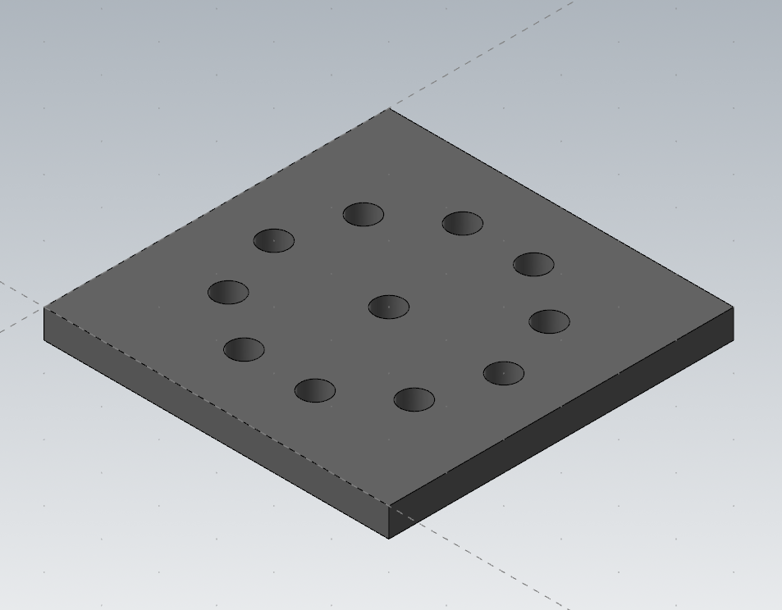

IV. Toolpaths:

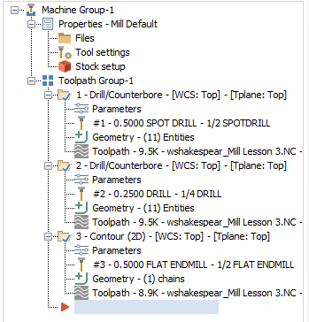

V. ½” Spot Drill Toolpath

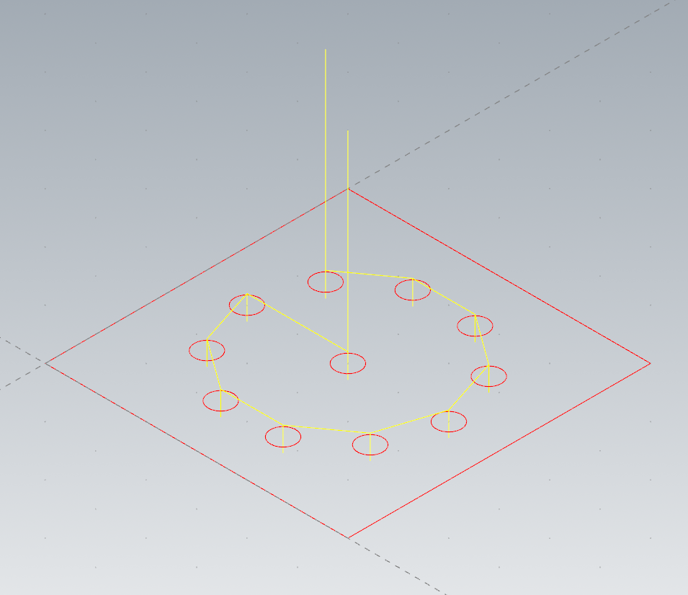

VI. ¼” Drill Toolpath

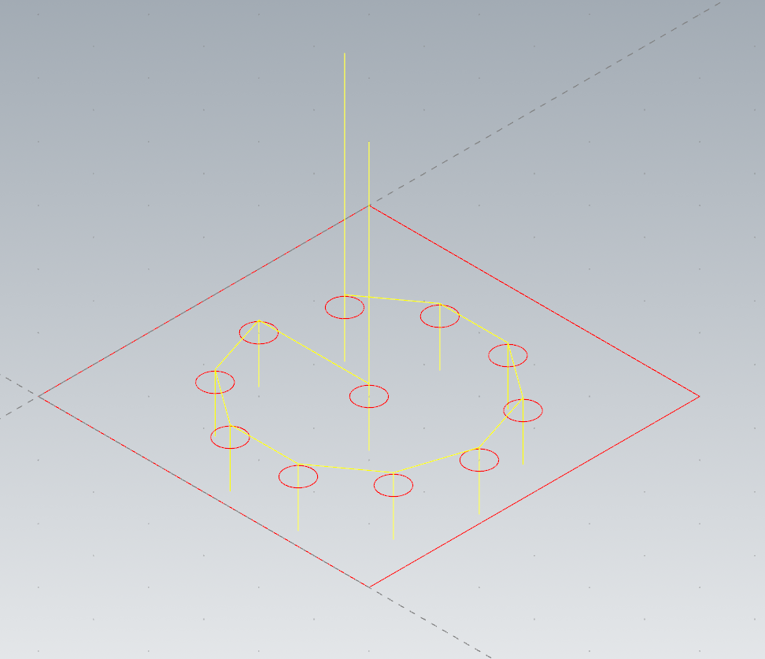

VII. ½” Endmill Contour Toolpath

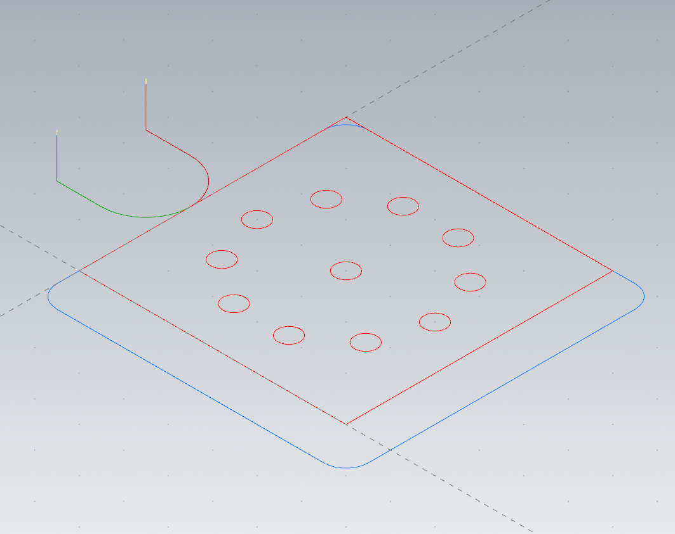

VIII. Verified Toolpaths

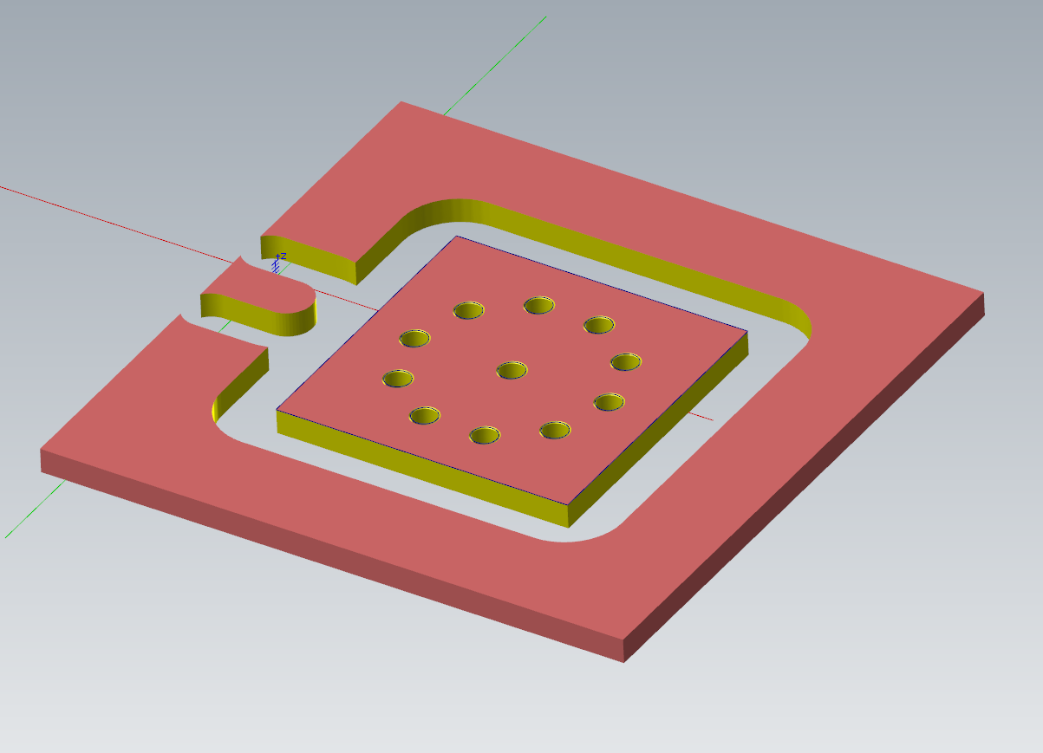

IX. Method:

I started by drawing a 3 x 3 square, then I added the center circle and one of the other circles with offsets and copying. Then I followed the tutorial for creating the polar “array”. After this I just followed the tutorial for creating the toolpaths.